Gender Pay Gap Report 2023

Foreword

2023 was a significant year for Wren Sterling as our employee community grew beyond 250 colleagues for the first time. We have always committed to creating a fair and inclusive culture, where we harness our individual experiences to develop a collective and collaborative approach to providing the best outcomes for our clients. 2023 is our first year of reporting on the Gender Pay Gap, and this marks the starting benchmark from which we will be measured going forwards.

We do not pay people differently based on their gender. Where pay gaps do exist within our organisation this is due to low representation of specific gender groupings in key disciplines within our business. To a very large extent, this reflects the challenges faced by us and the broader independent financial advice (IFA) industry in finding new ways to engage and encourage more female colleagues into the rewarding career of providing financial advice to clients. We have made good progress to increase female representation within our management and executive teams but have more work to do and we understand that this will take time.

In this report we set out our initial actions to respond to the challenge of ensuring our business reflects the communities we serve, ensuring we provide a better experience for our clients, our colleagues and stakeholders.

The following information reflects the Gender Pay Gap within Wren Sterling as of 5th April 2023.



**Stephen Williams**

**Director of Human Resources**

Our Core Values

Working closely with our colleagues, we have created four values that form the foundation of our brand and our culture as they define how we seek to behave towards our clients, our partners and each other:

We place emphasis on employee development so that colleagues have the opportunity to define a fulfilling and challenging career in every area of our business. We also aspire to make an impact within our local communities, and take our Corporate Social Responsibilities seriously, providing opportunities for colleagues to volunteer, undertake fundraising and develop awareness of all aspects of equality, diversity and inclusion. This is an ongoing process, matching our aspiration to be a ‘developer’ organisation, placing learning at the forefront of what we do.

Gender Pay Gap Reporting: Explained

Gender Pay Gap Legislation requires all businesses with more than 250 employees to calculate and publish data on Gender Pay Gap data on an annual basis. All businesses provide this snapshot based on data on 5th April of every year. Specifically, the reported data is as follows:

* Mean average Pay Gap for hourly pay between Male & Female employees.
* Median average Pay Gap for hourly pay between Male & Female employees.
* The percentage of Male & Female employees receiving bonus pay.
* Mean Bonus Pay Gap between Male & Female employees.
* Median Bonus Pay Gap between Male & Female employees.
* The percentage of Male & Female employees in each hourly pay quartile within the business

This provides the basis of Gender Pay Gap reporting, allowing comparisons to be made between companies and industries.

Gender Pay Gap

Commentary

Gender Pay Gap – Mean

38%

Gender Pay Gap - Median

35%

The primary reason for the existence of a Gender Pay Gap within Wren Sterling is due to under representation of females within Wren Sterling with 42% of employees being female in comparison to 58% being male.

The Gender Pay Gap is amplified by the lower level of female representation within the generally higher paid Financial Adviser and Executive level population. Our position mirrors an industry wide issue around attracting women into careers as an adviser, with only 16% of advisers being female. Currently 12% of Wren’s Adviser / Sales Management population are women indicating that we have work to do to encourage more women to consider a career within this key area.

Gender Pay Gap: Quartiles

Lower Quartile

Lower Middle Quartile

Upper Middle Quartile

Upper Quartile

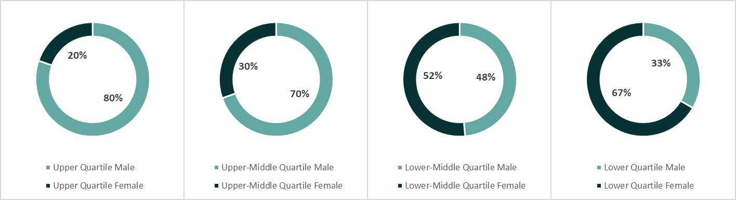

59% of all part time employees are female, with a high concentration of part time roles positioned within lower pay quartiles. This is due to colleagues proving a primary care role or as part of a planned reduction to retirement.

Gender Bonus Gap

Commentary

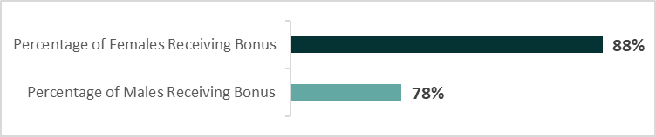

Gender Bonus Gap - Mean

92%

Gender Bonus Gap - Median

90%

While more females than males received a bonus, the value of the bonus paid is significantly higher on an annual basis for male rather than female employees due to the low level of representation of females in Adviser roles, which provide the highest levels of incentives and the widest variances in incentive payments.

At Wren Sterling, the highest concentration of female employees is in operational roles, and we have taken steps to provide non-advice bonus schemes within these areas over the last 3 years, although it is recognised that these schemes are remunerated at a lower level.

Insights & Actions

Following the results of our first ever Gender Pay Gap Report, we have focussed on some priority initial actions to reduce the gender pay gap within Wren Sterling and further encourage inclusivity within our business:

* **Review of Family Friendly Policies –** We have introduced our Agile (Hybrid) Working Policy, allowing colleagues at every level with the opportunity to work flexibly from various workplace settings. We have also conducted a market review of our Maternity and Adoption leave pay and policy, and now provide 13 weeks of full pay followed 13 weeks at half pay to support colleagues with primary care giving responsibilities.
* **Recruitment Audit -** We have conducted a full recruitment audit, focussing on ensuring that the language used in adverts, job descriptions and contract of employment are gender neutral. We have also reviewed our selection processes to ensure they are applied consistently throughout the organisation.
* **Diverse Candidate Pooling -** We have conducted a review of the preferred supplier list, engaging with agencies to provide a diverse candidate pool inclusive of gender, age, and ethnicity.
* **Networking & Development Opportunities -** We will be providing membership to Women in Banking & Finance to female colleagues in support of wider development opportunities.
* **Career Pathways -** We are responding to employee engagement requests for clearer signposting of developing a career at Wren Sterling, so colleagues can understand the level of support and opportunity available.
* **Diversity Awareness Days -** During 2023 / 2024 we are introducing Diversity Awareness Days, celebrating all aspects of diversity through education and to encourage social interaction. We are also rolling out Equality & Diversity training to all employees.
* **Wellbeing Support -** We have trained our Line Management teams as Mental Health First Aiders to support employee wellbeing within the workplace. We have also provided colleagues with a range of support through our Flexible Benefits programme which includes a range of Private Healthcare options, Employee Assistance Programme, and access to online Digital GP services.

Declaration

We confirm that our date is accurate and has been calculated according to the requirements of the Equality Act 2019 (Gender Pay Gap Information) Regulations 2017.

**James Twining Steve Williams**

**Chief Executive Officer Director of Human Resources**